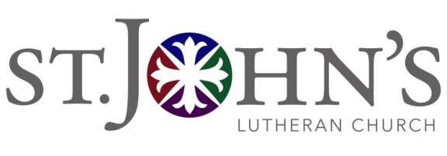
December 18, 2018
Church Council Meeting

Council Members Present: Pastor Frank Espegren, Pastor Jon Haug, Gwynnae Byrd, Lisa Berg, Ted Norris, Kim Hendricks, Bob Huckfeldt, Dean Petersen, Devin Hill, Lisa Gardiner, Nick Zylstra, Linda Baldwin

Guests Present: Lynne Gilbertson

Absent: Charlene Singley Joel Kimmelshue, Karen Ross, Rebekah Turnbaugh
Topics:

- Call to Order @ 7:33pm - Gwynnae Byrd

- Approval of Minutes - Gwynnae Byrd
Motion to approve the November 20, 2018 minutes.
M/Ted Norris S/Dean Petersen Motion Passed with 100% approval

- 2019 Budget - Linda Baldwin, Pastor Frank

Pastor Frank presented information regarding the pledges that have been received to date which total just over $1million. Council discussed income, expenses and ways to bring in donor that have not been giving previously. The proposed budget will be modified before the January Council meeting.

- Updates -Pastor Frank
  - The nominating committee will be meeting this week to discuss the 5 openings on the Council: two for members who are finishing their 2nd and final term and three who are finishing their 1st term and are eligible for a 2nd term. Officers for the Council will be elected after the installation of the new Council members.
  - Pledges for the roof capital campaign are still coming in. Pastor Frank and Gwynnae have talked to Diane White about her interest in working with the campus planning committee. The Policy Advisory Committee will be drafting a commissioning mandate at their January meeting.
  - Pastor Jon reports that the Scholarship Committee needs two new members.

- Old Business
  - Call Committee

The Committee has conducted video interviews with five candidates and will be proceeding with narrowing the candidate pool.

  - Social Ministries Committee report

Amy Chance submitted an annual report from the committee detailing all of the work completed during the year. Amy will be stepping aside as the chair of the committee and Rebekah is working to find a new chairperson.

  - Facilities planning

Discussed under updates above

  - Bylaws/Constitution
Council will be following up with the administrative side of the newly passed bylaws. The Constitution will be voted on at the January congregational meeting.

- New Business – Gwynnae Byrd

  - A discussion was held regarding the desire for evening services and the ways in which this could be a growth opportunity for the congregation.

- Announcements – Gwynnae Byrd

Adjourned at 9:30 pm
Next Meeting January 15 at 7:00pm

Respectfully Submitted,
Kim Hendricks
Church Council Secretary

